

32bits DSP Digital Audio Signal Process Module

Specification Sheet

Part Number：SNC8600BMT02

Rev: V1.1

19/08/2021

深圳市九音科技有限公司

深圳市南山区粤海街道科技南十二路18号长虹科技大厦

0755 - 86662489

WWW.SOUNDEC.COM

声明

本规格书由深圳市九音科技有限公司版权所有，未经许可，任何单位和个人都不得以电子的、机械的、磁性的、光学的、化学的、手工的等形式复制、传播、转录和保存该出版物，或翻译成其他语言版本。一经发现，将追究其法律责任。

九音科技保证本规格书提供信息的准确性和可靠性，但并不对文本中可能出现的文字错误或疏漏负责。九音科技保留更改本手册的权利，如有修改，恕不相告。请在订购时联系我们以获得产品最新信息。对任何用户使用我们产品时侵犯第三方版权或其他权利的行为本公司概不负责。另外，在九音科技未明确表示产品有该项用途时，对于产品使用在极端条件下导致一些失灵或损毁而造成的损失概不负责。

修订历史

|  |  |  |
| --- | --- | --- |
| 修订版本 | 修改日期 | 内容概要 |
| V0.1 | 2021/06/10 | 初版 |
| V1.0 | 2021/07/22 | 增加PIN脚定义说明 |
| V1.1 | 2021/8/19 | 修改通用版本 |
|  |  |  |

目录

1 产品概述 4

2模组介绍 5

2.1 尺寸 5

2.2 Pin脚定义 5

3 音频接口 7

3.1 ADC 特性 7

3.2 DAC 特性 7

3.3 Digital microphone interface 特性 8

4 外围接口说明 9

4.1 I2C 特性 9

4.2 UART 特性 9

4.3 I2S 特性 9

4.4 Auxiliary ADC 特性 10

5 参考电路设计 10

6 PCB Layout设计注意事项 11

# 1 产品概述

九音科技SNC8600BMT02模组是一款支持多麦克风阵列的语音前端解决方案。可以搭载九音科技的麦克多阵列算法,通过对讲话人的角度定位，形成定向拾音波束，并对波束以外的噪声进行抑制，以保证较高的拾音质量。

本模块主要有以下特性:

|  |  |
| --- | --- |
| System | * 200MHz 32bit HiFi DSP 处理器 * 集成512KB内存 * 集成ROM固件 * 集成 8M bits Flash * 支持24MHz无源晶振 * 工作电压: I/O 3.3V 或 1.8V * 支持PEQ,最大支持8段 |
| Audio | * 支持24位ADC和DAC的立体声,动态范围分别是106dB和110dB * 支持采样率: 8k, 16k, 32k, 44.1k, 48k, 88.2k, 96k, 176.4k, 192k * 2路模拟麦克风的输入 * 最多4路数字麦克风的输入 * 支持: 自动增益控制, 动态范围控制, 混音 |
| Power | * 3.3V到5.5V的单电源输入 * 支持3.3V单DC-DC调节CODEC模拟部分电压 * 支持3.3V单LDO为模拟部分提供电源 * 支持3.3V单LDO数字接口提供电源 * 支持2.5V的两路麦克风单独供电 * 功耗:   - 播放音乐 14mA@Vbat = 3.3V  - 通话 [16mA@Vbat=3.3](mailto:16mA@Vbat=3.3) |
| Interface | * 支持9 GPIO * 支持 1路Auxiliary ADC输入 * 支持4路硬件PWM * 支持Type-C接口,符合音频规范Rev1.0\Rev2.0版本 * 串行接口: I2S*2, UART*1, I2C*1 |
| Application | * USB声卡 * 会议音箱 * USB麦克风 * 其他音频产品 |

# 2模组介绍

## 2.1 尺寸

整板尺寸为14x14（mm），孔径为0.65mm。

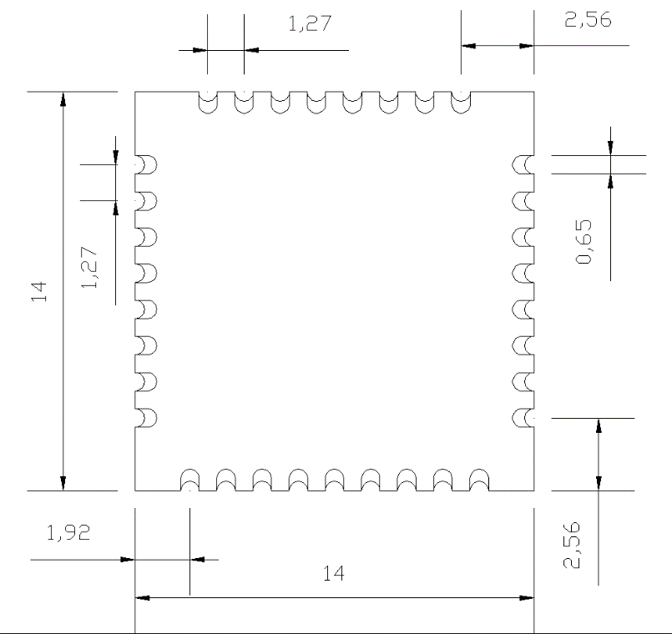

## 2.2 Pin脚定义

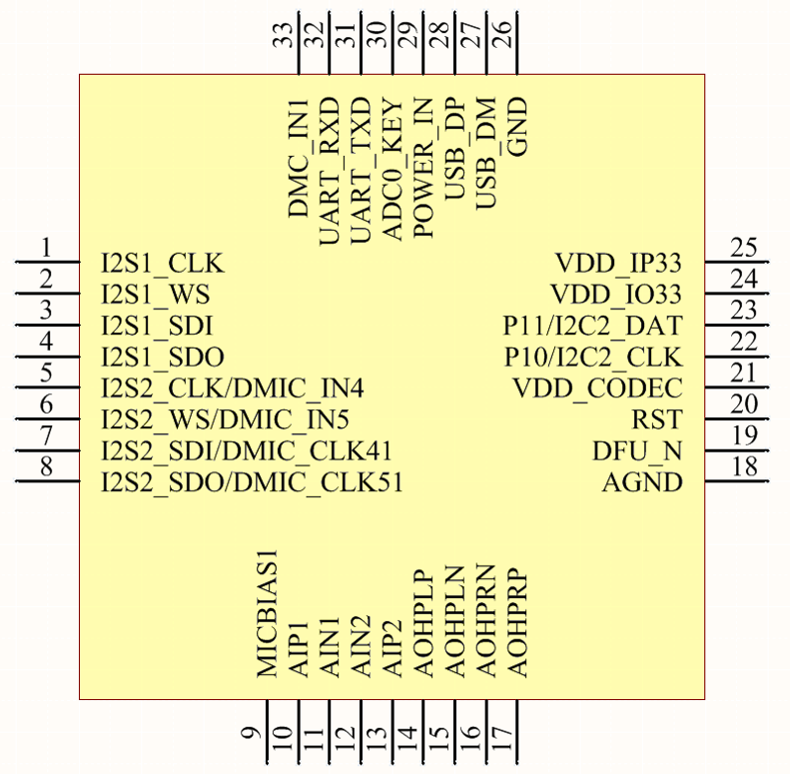

|  |  |  |  |
| --- | --- | --- | --- |
| Pin Number | Type | Pin Name | Description |
| 1 | I/O | I2S1_CLK/GPIO0 |  |
| 2 | I/O | I2S1_WS/GPIO1 |  |
| 3 | I/O | I2S1_SDI/GPIO2 |  |
| 4 | I/O | I2S1_SDO/GPIO3 |  |
| 5 | I/O | I2S2_CLK/DMIC_IN4/GPIO4 |  |
| 6 | I/O | I2S2_WS/DMIC_IN5/GPIO5 |  |
| 7 | I/O | I2S2_SDI/DMIC_CLK41/GPIO6 |  |
| 8 | I/O | I2S2_SDO/DMIC_CLK51/GPIO7 |  |
| 9 | Power | MICBIAS1 | Micbias 1 |
| 10 | Analog | AIP1 | MIC1 input P port |
| 11 | Analog | AIN1 | MIC1 input N port |
| 12 | Analog | AIN2 | MIC2 input N port |
| 13 | Analog | AIP2 | MIC2 input P port |
| 14 | Analog | AOHPLP | Left DAC P port |
| 15 | Analog | AOHPLN | Left DAC N port |
| 16 | Analog | AOHPRN | Right DAC N port |
| 17 | Analog | AOHPRP | Right DAC P port |
| 18 | Analog GND | AGND |  |
| 19 | I/O | DFU_N | Firmware update enable |
| 20 | I | RST | Chip reset |
| 21 | Power | VDD_CODEC | 3.3V for Codec |
| 22 | I/O | P10/I2C2_CLK |  |
| 23 | I/O | P11/I2C2_DAT |  |
| 24 | Power | VDD_IO33 | 3.3V for IO |
| 25 | Power | VDD_IP33 | 3.3V for analog block |
| 26 | GND | GND |  |
| 27 |  | USB_DM |  |
| 28 |  | USB_DP |  |
| 29 | Power | POWER_IN | External power supply |
| 30 | I | ADC0_KEY |  |
| 31 | O | UART_TXD | UART TX data |
| 32 | I | UART_RXD | UART RX data |
| 33 | I/O | DMC_IN1/GPIO9 |  |

# 3 音频接口

## 3.1 ADC 特性

|  |  |  |  |  |  |
| --- | --- | --- | --- | --- | --- |
| Condition: - 40°C to +100°C, AVDD=3.3Vm DVDD=1.1V. Input sine wave with a frequency of 1 kHz, measurement bandwidth 20 Hz - Fs/2 for Fs < 48 kHz, measurement bandwidth 20 Hz - 20 kHz for Fs = 48 kHz to 192 kHz, normal mode, capacitor-less input conﬁguration, unless otherwise speciﬁed. | | | | | |
| Parameter | Test condition | Min. | Typ. | Max. | Unit |
| Input level | Full Scale,Gain GID* = 0 dB, boost gain GIM* = 0 dB |  | 2.12 |  | Vpp |
| Full Scale, Gain GID* = 0 dB, boost gain GIM* = 20 dB |  | 0.212 |  | Vpp |
| THD+N | 1 kHz sine wave @ Full Scale -3 dB and gain GID* = 0 dB, boost gain GIM* = 0 dB, normal mode and low power mode |  | 88 |  | dB |
| Dynamic Range | A-weighted, 1 kHz sine wave, normal mode |  | 106.5 |  | dB |
| A-weighted, 1 kHz sine wave, low power mode |  | 103.5 |  | dB |
| SNR | A-weighted, 1 kHz sine wave, with activation of the SNR optimizer feature |  | 106 |  | dB |
| A-weighted, 1 kHz sine wave, gain GID* = 0 dB, boost gain GIM* = 0 dB, normal mode |  | 94.5 |  | dB |
| A-weighted, 1 kHz sine wave, gain GID* = 0 dB, boost gain GIM* = 0 dB, low power mode |  | 90.5 |  | dB |
| PSRR | 100 mVpp 1 kHz sinewave is applied to AVD, input data is 0 and gain GID* = 0 dB, boost gain GIM* = 0 dB |  | 90 |  | dB |

## 3.2 DAC 特性

|  |  |  |  |  |  |
| --- | --- | --- | --- | --- | --- |
| Condition: - 40°C to +100°C, AVDD=3.3Vm DVDD=1.1V. Input sinewave with a frequency of 1kHz, measurement bandwidth 20Hz-20kHz, unless otherwise speciﬁed. | | | | | |
| Parameter | Test condition | Min. | Typ. | Max. | Unit |
| Output level | Full Scale, gain GOL/R = +6 dB, GODL/R = 0 dB, 10 kOhms load |  | 5.6 |  | Vpp |
| Full Scale, gain GOL/R = +6 dB, GODL/R = 0 dB, 200 Ohms load |  | 5.6 |  | Vpp |
| Full Scale, gain GOL/R = +6 dB, GODL/R = 0 dB, 32 Ohms load |  |  | 3.96 | Vpp |
| Output power | 200 Ohms load |  | 19.6 |  | mW |
| 32 Ohms load |  |  | 61.3 | mW |
| SNR | A-weighted, 1 kHz sine wave @Full Scale, gain GOL/R = +6 dB, GODL/R = 0 dB, 10 kOhms load |  | 101 |  | dB |
| Dynamic Range | A-weighted, 1 kHz sine wave @ Full Scale, gain GOL/R = [-10 +6] dB, GODL/R = 0 dB, 10 kOhms load |  | 110 |  | dB |
| Idle Noise | A-weighted with no signal, gain GOL/R=-10dB, GODL/R = 0 dB, 10k Ohms load |  | -104.9 |  | dBV |
| THD+N | 1 kHz sine wave @ Full Scale -1 dB, gain GOL/R = +6 dB, GODL/R = 0 dB, 10 kOhms load |  | 87 |  | dB |
| 1 kHz sine wave @ Full Scale -1 dB, gain GOL/R = +6 dB, GODL/R = 0 dB, 200 Ohms load |  | 85 |  | dB |
| 1 kHz sine wave @ Full Scale -1 dB, gain GOL/R = -3 dB, GODL/R = 0 dB, 32 Ohms load |  | 79 |  | dB |

## 3.3 Digital microphone interface 特性

|  |  |  |  |  |  |
| --- | --- | --- | --- | --- | --- |
| Condition: Input sine wave with a frequency of 1 kHz, MCLK = 12 MHz or 13 MHz, DMIC_CLK = Fmclk/4, measurement bandwidth 20 Hz - Fs/2 for Fs = 8 to 32 kHz, measurement bandwidth 20 Hz - 20 kHz for Fs = 44.1 kHz to 192 kHz, unless otherwise speciﬁed. | | | | | |
| **Parameter** | **Test condition** | **Min.** | **Typ.** | **Max.** | **Unit** |
| Input level | Full Scale max value, Gain GID* = 0 dB |  | 85.6 |  | % |
| Full Scale min value, Gain GID* = 0 dB |  | 14.4 |  | % |
| SNR | A-weighted,1kHz sinewave @Full Scale and gain GIDL, GIDR = 0 dB |  | 100 |  | dB |
| Dynamic Range | A-weighted, 1 kHz sine wave @ Full Scale -60 dB and gain GID* = 0 dB |  | 100 |  | dB |
| THD+N | 1kHz sinewave @Full Scale-1dB and gain GIDL, GIDR = 0 dB |  | 90 |  | dB |
| Digital gain | Gain GID* when activated | -64 |  | 63 | dB |
| Gain step | GID* @1 kHz |  | 1 |  | dB |
| Gain accuracy | GID* @1 kHz | -0.25 | 1 | +0.25 | dB |

# 4 外围接口说明

## 4.1 I2C 特性

|  |  |  |  |  |
| --- | --- | --- | --- | --- |
| Item | Quantity | Unit | Specification | Comment |
| I2C | 2 | kbps | Up to 400 |  |

## 4.2 UART 特性

|  |  |  |  |  |
| --- | --- | --- | --- | --- |
| Item | Quantity | Unit | Specification | Comment |
| UART | 1 | bps | Up to 3M | TX and RX |

## 4.3 I2S 特性

|  |  |  |  |
| --- | --- | --- | --- |
| Item | Unit | Specification | Comment |
| Interface number |  | 3 I2S interface, with word clock, bit clock, data-in, data-out |  |
| Word clock | kHz | Up to 192 | 8, 16, 32, 44.1, 48, 88.2, 96, 176.4, 192 |
| Data width | bits | 16/20/24 |  |
| Format |  | Standard, left-justified, right-justified |  |

## 4.4 Auxiliary ADC 特性

|  |  |  |  |  |
| --- | --- | --- | --- | --- |
| Parameters | Min | Typ | Max | Unit |
| Resolution |  | 12 |  | Bits |
| ENOB |  | 11 |  | Bits |
| Sampling rate |  | 5.0 |  | Msps |
| Channel |  | TBD |  |  |
| AVDD-aux-ADC |  | 3.3 |  | V |
| DVDD-aux-ADC |  | 1.1 |  | V |
| Input voltage range | 0 |  | 3.3 | V |
| INL accuracy | -2 |  | +2 | LSB |
| DNL accuracy | -1 |  | +1 | LSB |
| Offset | -2 |  | +2 | LSB |
| Gain error | -1 |  | 1 | % |
| Hardware conversion time |  | 1.0 |  | Us |

# 5 参考电路设计

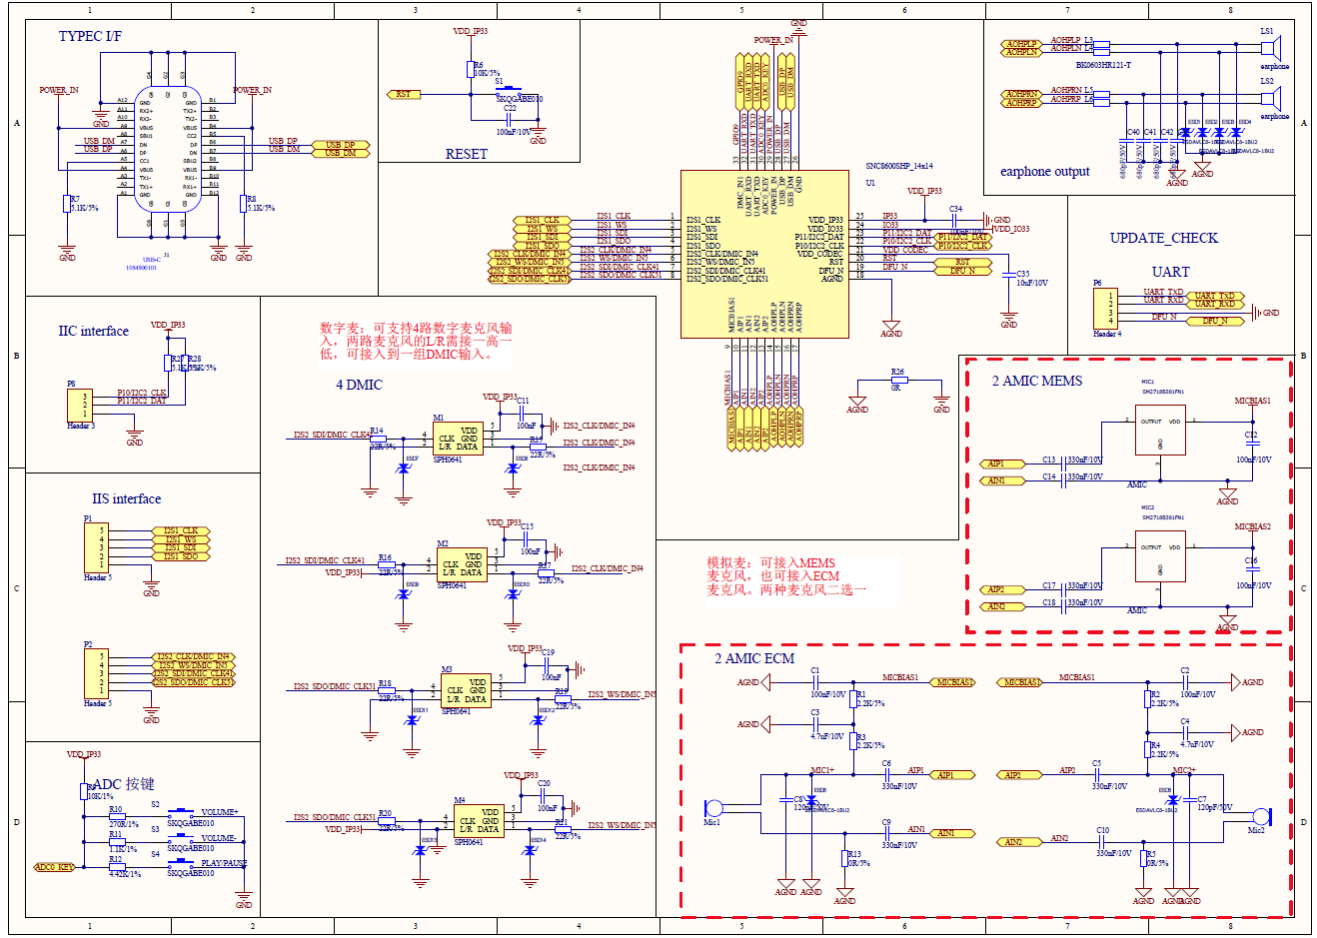

# 6 PCB Layout设计注意事项

1. 模拟麦克风输入需要做包地处理，减小外接干扰。
2. 数字麦克风输入CLK和DAT信号线需要走差分线,并包地处理。



1. DAC输出LP/LN和RP/RN 需要走差分线并包地处理。

